Embedding Language Development into the Content Areas

**Online Registration: events.misd.net**

* Login or create a new account
* Search for Course in search bar
* Click on Course name and “Add to Cart”
* Click on “Checkout” and follow prompts
* You will receive an email confirmation

Send payment via VANMAIL or US Mail to:

**Macomb Intermediate School District**

**44001 Garfield Rd.**

**Clinton Twp., MI 48038**

**Attn: Alex Bryan**

REGISTRATION IS A COMMITMENT OF PAYMENT OF ATTENDANCE. All cancellations must be received in writing 7 days prior to the beginning of the workshop.

**SCECHs** pending approval (additional cost applies)



This three day series will include an overview of the process of language development, exploration of current research and best practices related to English Learners. Participants will take a deep dive into the key components of the SIOP model, and learn how to tailor instruction to meet the needs of their culturally and linguistically diverse students. This training will also give participants a deeper understanding of the WIDA framework, and how to adapt instruction according to the various levels of WIDA proficiency, using the Can Do Descriptors, so that ALL learners can successfully grasp grade level content.

Participants will receive a copy of the text, ***Making Content Comprehensible for English Learners, The SIOP Model*** and additional materials.

**Target Audience:** All instructional staff that work with English Learners.

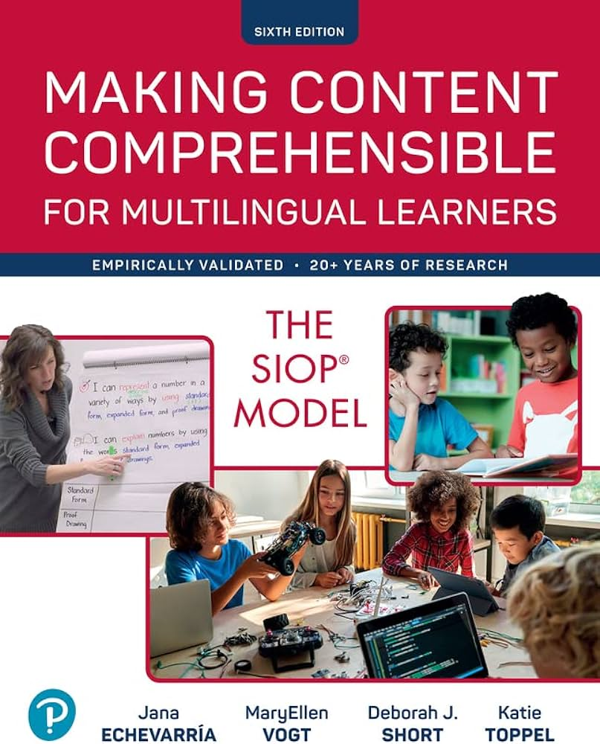

**Dates**: April 22, April 30 and May 14, 2025

**Time:** 9:00 a.m. - 3:30 p.m.

**Location:** **Harry L Wheeler Community Center**

**24076 F.V. Pankow Blvd.**

**Clinton Township, MI 48036**

**(L’Anse Creuse Public Schools)**

**Cost:** $100 (includes text and materials)

**Presenters:** Dr. Su McKeithen-Polish and Laura Crouter, MISD English Language Development Consultants

Using SIOP and Other Strategies for

English Learners